**Task 1:**

Write a C++ functions-based program that will calculate and print the parking charges for each of 3 customers who parked their car in the car park yesterday. The program should accept as input the number of hours that each customer was parked, and saves the results in a neat tabular form in a file, along with the total receipts from the three customers:

**Sample Output:**

## 

**Program :**

#include<iostream>

#include<iomanip>

using namespace std;

float charge(float hour)

{

float a = hour;

float charge = 2.0;

if (a > 0)

{

if (a <= 3)

{

return charge;

}

else if (a <= 24)

while (a > 3)

{

charge += 0.5;

a--;

if (charge >= 10)

charge = 10;

}

return charge;

}

else

{

cout << "No car parks longer than 24 hour.";

}

}

int main()

{

int soul;

float x, y, z;

float hour;

for (soul = 1; soul <= 3; soul++)

{

cout << "Enter car " << soul << " parking hours: ";

cin >> hour;

if (soul == 1)

{

x = hour;

}

else if (soul == 2)

{

y = hour;

}

else

{

z = hour;

}

}

cout << endl;

cout << setw(12) << left << "Cars " << left << setw(12) << "Hours" << left << setw(12) << "Charges" << endl;

cout << setw(12) << left << " 1" << left << setw(12) << x<< left << setw(12) << charge(x) << endl;

cout << setw(12) << left << " 2" << left << setw(12) << y << left << setw(12) << charge(y) << endl;

cout << setw(12) << left << " 3" << left << setw(12) << z << left << setw(12) << charge(z) << endl;

cout << setw(12) << left << "Total" << left << setw(12) << x + y + z << left << setw(10) << charge(x) + charge(y) + charge(z) << endl;

return 0;

}

**Screen Shots :**

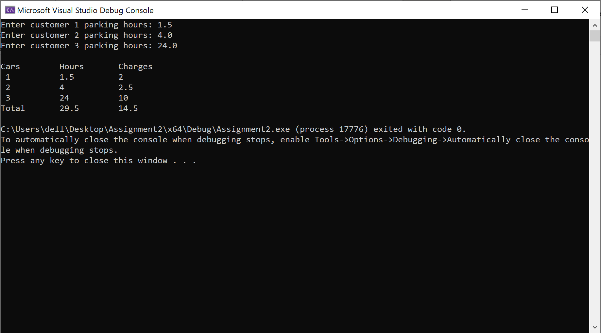

**Task 2:**

Write a function ***rota;te*** that takes two integer ***a*** and ***pos*** as parameters and rotate ***pos*** digits of ***a***. For example, given **a** = 12345 and **pos**=3, after execution of function **rotate** new value of ***a*** would be 34512.

**Sample output:**

Your function should work for the following driver function

|  |
| --- |
| int main( ){  int a=12345;  rotate(a,2);  cout<<a; ***//should output rotated value of a i.e. 45123***  } |

**Program :**

#include<iostream>

using namespace std;

int power(int n)

{

int sum = 1;

for (int i = 0; i < n; i++)

{

sum = sum * 10;

}

return sum;

}

int rotate(int& a, int pos)

{

int temp;

int c = 0;

temp = a;

int sum = 0;

int x = 0;

while (temp > 0)

{

c++;

temp = temp / 10;

}

x = c - pos;

sum = a % power(pos);

sum = sum * power(x);

a = a / power(pos);

a = a + sum;

return a;

}

int main()

{

int a = 12345;

int pos = 3;

cout << rotate(a, pos) << endl;

return 0;

}

**Screen Shots :**

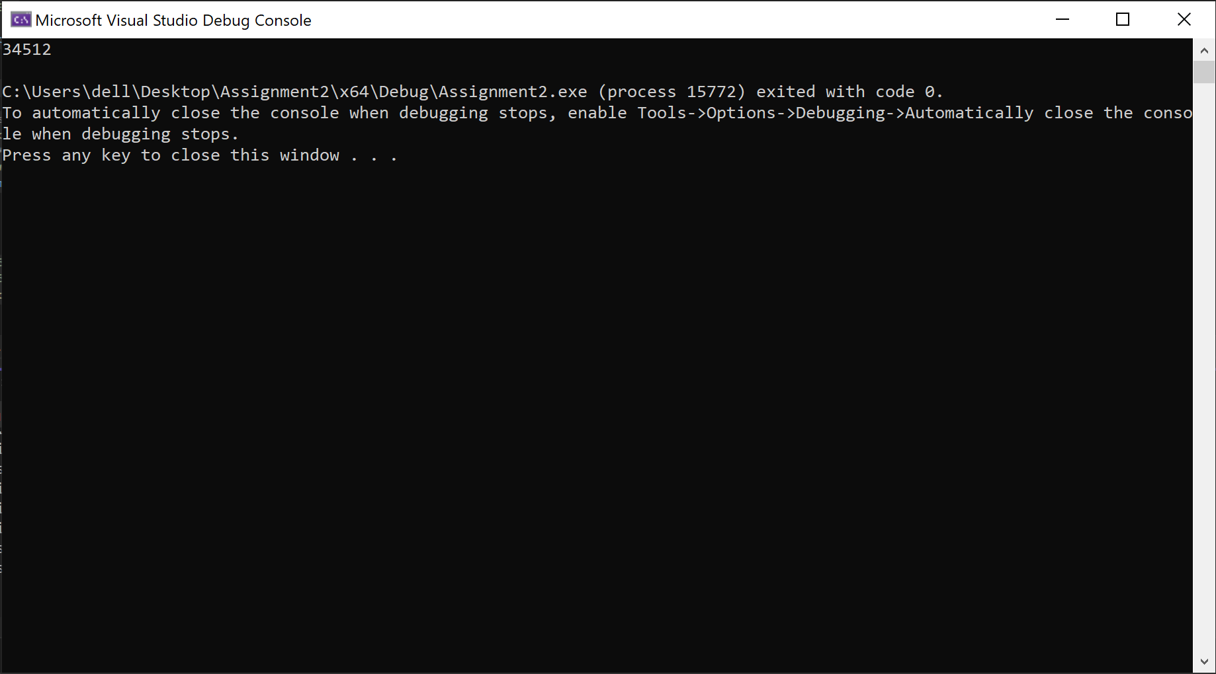

**Task 3:**

Write 4 different functions to perform the operations as explained below. These functions will receive only 2 variables and return nothing but perform the following tasks:

**Main =>** call all 5 functions one by one, by passing 2 variables.

**InvisibleSwap =>** receive 2 integers, swap them, but this swap will not visible in main

**visibleSwap =>** receive 2 integers, swap them, but this swap will visible in main

**InvisibleSwapByPointer =>** receive 2 integer pointers, swap their values, but this swap will not visible in main.

**visibleSwapByPointer =>** receive 2 integer pointers, swap their values, but this swap will visible in main.

**Sample output:**

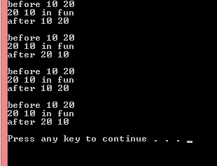

**Program :**

#include<iostream>

using namespace std;

void i_swap(int a, int b);

void swap(int& a, int& b);

void pi_swap(int a, int b);

void p_swap(int* a, int* b);

int main()

{

int a = 10;

int b = 20;

int* ptra;

int* ptrb;

ptra = &a;

ptrb = &b;

cout << "before " << a << " " << b << endl;

i_swap(a, b);

cout << "after " << a << " " << b << endl << endl;

cout << "before " << a << " " << b << endl;

swap(a, b);

cout << "after " << a << " " << b << endl << endl;

a = 10;

b = 20;

cout << "before " << a << " " << b << endl;

pi_swap(*ptra, *ptrb);

cout << "after " << a << " " << b << endl << endl;

cout << "before " << a << " " << b << endl;

p_swap(ptra, ptrb);

cout << "after " << a << " " << b << endl << endl;

return 0;

}

void i_swap(int a, int b)

{

int temp = 0;

temp = a;

a = b;

b = temp;

cout << a << " " << b << " in fun" << endl;

}

void swap(int& a, int& b)

{

int temp = 0;

temp = a;

a = b;

b = temp;

cout << a << " " << b << " in fun" << endl;

}

void pi_swap(int a, int b)

{

int temp = 0;

temp = a;

a = b;

b = temp;

cout << a << " " << b << " in fun" << endl;

}

void p_swap(int* a, int* b)

{

int temp = 0;

temp = *a;

*a = *b;

*b = temp;

cout << *a << " " << *b << " in fun" << endl;

}

**Screen Shots :**

